PI-IYS 110 Some selected questions.

If you can do these, you have mastered enough of the material to do fine.

1. A particle's position is given by *x(t) t* — 21-t2 + (2m + 1111 *t))$'.*

1. What is the velocity at t=2s? What is the speed?
2. What is the acceleration at t=3s? If the particle has a mass of 2kg, what is the magnitude of the force it experiences?
3. What is the angle between the position and acceleration vectors at t-----0.5s?
4. If the particle has a mass of 3kg, what is the rate at which its kinetic energy is changing at t=1.5s?

2. A particle's velocity is given by = 2 + 3 4-t*2* )^

1. What is its displacement between t=2s and t=3s?
2. What is its acceleration at t=ls?
3. What is its kinetic energy at t=0.5s if it has a mass of 1kg?

3. A particle moves only along the x-axis, and is subject to a force towards the origin of

Magnitude toc3 . If the particle moves from x1 to x2 how much work does this force do on it? (Consider the case x1 < x2). If this were a *conservative* force, what would the change in potential energy be?

4. A 2kg particle is launched at a speed of 30m/s at an angle of 25 degrees above the horizontal.

1. How far does it travel over level ground?
2. If it lands 2m above the launch point how long would that take?
3. If it lands 2m below the launch point how long would that take?
4. How long does it take to reach the top of its flight?
5. What is the maximum height it reaches?
6. What is the kinetic energy when launched?
7. What is the kinetic energy at the top of the flight?
8. What is the gravitational potential energy at the top of the flight?
9. Make sure you can do this kind of problem for other input numbers.

5. A 3kg object is launched at an angle of 35 degrees above the horizontal.

1. It travels 25m over level ground, what is its launch speed?
2. It hits a tree 5m tall and 10m away. What was the launch speed?

6. A block sits on a plane with which it has a coefficient of friction of 0.5. What is the maximum angle that the plane can make with the horizontal before the block starts to slip?

7. A mass is held up by 3 ropes. One has a tension of 100N and makes an angle of 25 degrees to the right of vertical, one has a tension of 200N and makes an angle of 45 degrees to the left of vertical, and one is horizontal.

1. What is the suspended mass?
2. What is the direction of the force the third rope exerts? (left or right)
3. What is the tension in this third rope?

8. A massless ladder of length L has a mass M one-third of the way up, and a mass 2M two-thirds of the way up. It leans against a frictionless wall. The feet of the ladder have a coefficient of static friction of 0.6 with the ground. What is the biggest angle the ladder can make with the wall before the ladder slips?

9. A massless beam of length 10m makes an angle 30 degrees to the left of vertical. It

Supports a 10kg mass at its top end. The top end is also supported by a horizontal rope which connects to the top of a uniform 12.2m long beam which makes an angle 45 degrees to the right of horizontal. The bottoms of both beams are fixed in place by a pin. What is the mass of the 12.2m beam?

10. A spring with spring constant k=100N/m supports a 5kg mass against gravity.

1. By how much is the spring stretched?
2. What was the increase in the potential energy in the spring compared with then the mass was not attached?
3. What was the decrease in gravitational potential energy of the mass as it goes down to the equilibrium position?

11. A mass of 3kg sits on a scale in an elevator. The scale measures the normal force between the mass and the floor of the elevator. What is the reading when:

1. The elevator is stationary?
2. The elevator rises at a constant speed of 2m/s?
3. The elevator descends at a constant speed of 2m/s?
4. The elevator accelerates upwards at 2m/s2?
5. The elevator accelerates downwards at 2m/s2?

12. A 5kg mass sits on a horizontal surface with which it has a coefficient of friction of 0.2.

It is attached via a rope which goes over a massless, frictionless pulley, to a 4kg mass.

1. What is the acceleration of the 5kg mass?
2. What is the tension in the rope?
3. What would happen (qualitatively) if the pulley were not massless?

13. A car goes into a curve of radius R at speed V. The coefficient of friction between the car and the road is 0.7.

1. If the curve is not "banked" and R=50m, what is the biggest V such that the car won't skid?
2. If the curve is banked at an angle of 20 degrees, and R=50m, what value of V will result in no frictional force on the car?
3. If the curve is not banked and the driver is going at speed V described in part a, what will happen when the drive touches the brakes? Why?

14. A l kg mass goes down a slide which then puts it into a loop-the-loop of radius l m.

1. At the top of the loop, the normal force on the mass is 5N. How high did it start?
2. At the top of the loop the normal force is 5N, what is the normal force at the bottom?
3. Suppose that instead the I kg mass was a ball (1=2/5 M R2) which rolled without slipping. What would the answers for a and b be in this case?

15. A 5kg mass goes along a horizontal frictionless surface, then it passes over a region where the coefficient of kinetic friction is 0.2.

1. If the mass started at a speed of 6m/s, how far would it go before it stopped?
2. If the mass started at a speed of 5m/s and the region was 2m wide, what would the change in momentum of the mass be after going over the region?
3. If the mass started at a speed of 6m/s and the region was 3m wide, and then passed over another frictionless surface until it hit a spring with spring constant 1000N/m, what is the spring's maximum compression?
4. Repeat c with it going up a ramp sloped at 20 degrees above the horizontal (and no spring) How far up does it get?

16. A 2kg mass going at 3m/s along the x-axis hits and sticks to a 3kg mass going at an angle of 45 degrees to the x-axis at 4m/s (both the x and y components of its velocity are negative)

1. What direction does the combined mass move after the collision?
2. What speed does the combined mass move after the collision?
3. How much work was done by non-conservative forces in the collision?
4. If the collision lasted for 0.01s, what was the average force on the 2kg mass?

17. A 2kg mass traveling at 10m/s along the x-axis hits a 5kg mass initially at rest. The collision is elastic.

1. What is the velocity of the 5kg mass after the collision?
2. What is the velocity of the 2kg mass after the collision?
3. What is the change in momentum of the 5kg mass?
4. What is the final momentum of the 2kg mass?

18. A ring of radius 1.2m and mass 2kg rolls without slipping along a flat surface.

1. The ring moves at 6m/s. What is its angular speed?
2. What is the total kinetic energy?
3. What is the tangential speed of any point along the surface of the ring?

19. A disk of radius 0.2m rotates 6 times each second.

1. What is its angular speed?
2. What is the tangential speed on a point on the edge of the disk?

20. A satellite of mass 600kg orbits in a circle at a distance of 2x107 m away from the center of a planet of mass 2.4x1024kg.

1. What is the period of this orbit?
2. What is the speed of this satellite?
3. What is the force that the satellite experiences?
4. What is the satellite's kinetic energy?
5. What is the satellite's potential energy?
6. What is the period of an object that moves in a circle of radius 4x107m from the planet?

21. A -5x10-3C charge is at the origin, a 4x10-3C charge is at 1m2, and a 6x10-3C charge is at —1m2 +

1. What is the force on the charge at the origin?
2. What is the electric potential energy of the charge at the origin?
3. What is the electric field at the origin?

D. How much work would you have to do on the charge at the origin to move it to *5m2?*

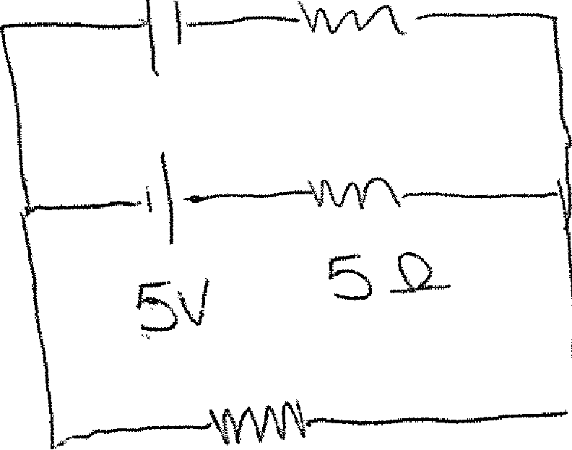

SI-

22. A 5x104c charge is fixed at the origin. A -4x10-4C charge of mass 1kg is initially at 2m2. It initially has a velocity of 401: 2.

1. What is the maximum separation between these charges?
2. What is the speed of the negative charge when it is at 4m2?
3. What is the potential difference between where the negative charge started and where it "turns around"?

23. A 3.2x10-19C ion with mass 2.6x10-25kg travels at an initial velocity of *.1;* = 200071 2 in a

Region where there is a uniform magnetic field of 0.35T 1.

1. It moves in a circle; what is the radius of that circle?
2. Where is the center of the circle?

24. An ion of mass 5.2x10-25kg and charge 4.8x10'19c starts at rest in a region where the electric field is 1000 v*--x.* When it has moved d = 2m 2 it enters a region were there is

*Also* a constant magnetic filed.

1. What speed will the ion be moving at when it enters the magnetic field?
2. Assuming that the magnetic field is in the z direction, describe qualitatively what happens to the ion.
3. Given that the magnetic field is in the z direction, what is the magnitude such that an ion might experience no force (for a speed as given in 'a') and what direction must the ion be travelling?

25. There are five 100 Q resistors connected as shown in the diagram below connected to a I OV battery.

1. Find the equivalent resistance of the resistor configuration.
2. Find the rate of energy dissipation in each resistor.
3. Find the current through each resistor.
4. Find the potential difference between the negative pole of the battery and the place labeled 'a'.

26. For the circuit drawn below, find the current (magnitude and direction) in each resistor.

10

